INS3121
SOIL MECHANICS
MIDTERM I
09.11.2015

Name and Surname:
Q.1 | Q.2 | Q.3 | Q.4 | TOTAL
Number:
Group:

- The natural unit weight (γ_{n}) of a sand backfill was determined by field measurements to be 18 kN/m³. The water content at the time of the test was 8.6%, and the specific gravity of solid constituents was 2.65. In the laboratory the void ratios in the loosest and densest states were found to be 0.642 and 0.462, respectively. What are the dry unit weight (γ_{d}), void ratio (e), porosity (n), relative density (D_{r}), and the degree of saturation (S) of the fill?

Name and Surname: Number: Group:
- Classify the soils, for which the grain size distribution and consistency limits are given below, according to Unified Soil Classification System (USCS) and American Association of State Highway and Transportation Officials (AASHTO) Classification System. Which soil given below can be used in a core layer of an earth dam?
Soil B
Sieve No. | Percent finer (%) |  | Atterberg Limits
# 4 |  | 100 | LL = 68
#10 |  | 80 | PL = 57
#40 |  | 72
#100 |  | 61 | Inorganic soil
#200 |  | 55
D₁₀ |  | 0.002 mm
D₃₀ |  | 0.005 mm
D₆₀ |  | 0.15 mm
Soil A
Sieve No. | Percent finer (%) | Atterberg Limits
# 4 | 90 | LL = 45
# 10 | 78 | PL = 30
# 40 | 55
# 100 | 35 | Inorganic soil
# 200 | 8
D₁₀ | 0.09 mm
D₃₀ | 0.15 mm
D₆₀ | 0.5 mm

Name and Surname: Number: Group:
- A flow net under a concrete dam lying on a permeable soil over impermeable layer is given figure. A 30 cm high soil sample with a cross-sectional area of 30 cm² is placed in the constant head hydraulic conductivity test to determine permeability coefficient of the sandy soil. A volume of 200 cm³ of water over a time of 900 seconds has been collected in the container (Δh=55 cm). Based on this information:
- Determine the permeability coefficient (k) of the silty sand soil.
- Calculate the seepage loss under concrete dam per unit width.
- Calculate the water pressures at points A, B, and C.
- Determine whether there is a quick sand condition at the point D or not.

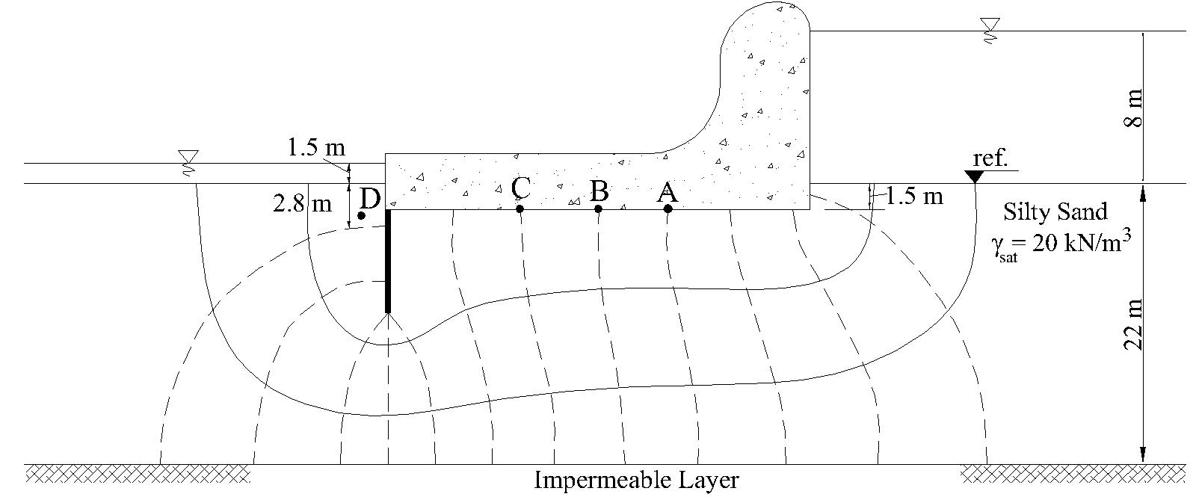

Name and Surname: Number: Group:
- a) What is the Atterberg Limits and which experiments are used to determine Atterberg Limits. Plot the relationship between volume change and moisture content curve of Atterberg Limits. What is the importance of Atterberg Limits in engineering purpose? Explain briefly.
b) Explain the uniform soil and well-graded soil terms
c) What is the importance of grain size distribution in engineering purpose?
c) Write down Darcy’s Law equation and explain terms briefly.
d) What is flowing sand (quick sand) condition? Briefly explain.

Time is 80 minutes. Good Luck…

